AI-Driven Ocular Screening: The Swalife Eye Diagnostic Tool
Dr Pravin Badhe¹*
¹Swalife Biotech Ltd, North Point House, North Point Business Park, Cork (Republic of Ireland)
drpravinbadhe@swalifebiotech.com*

Abstract
Early detection of ocular and neurological disorders increasingly relies on artificial intelligence (AI) to complement traditional clinical examination. The Swalife Eye Diagnostic Tool represents a comprehensive AI-assisted platform designed to analyze eye images and videos for risk estimation of cataract, glaucoma, diabetic retinopathy, and neurological indicators such as Parkinson’s disease and Alzheimer’s disease. By integrating image processing pipelines with machine learning models and oculomotor analytics, the tool enables rapid, non-invasive, and scalable disease screening. This article presents the architecture, methodology, and case study outcomes highlighting the tool’s ability to evaluate ocular health and movement-based neurological markers efficiently.
Keywords:
AI Ophthalmology, Eye Disease Detection, Glaucoma Screening, Saccadic Analysis, Digital Diagnostics, Swalife Platform

1. Introduction
Accurate and early detection of ocular diseases remains a global challenge, contributing significantly to preventable vision loss. Traditional eye examinations require specialized expertise, equipment, and clinical visits, which may limit accessibility particularly in remote or resource-constrained regions. Simultaneously, emerging research demonstrates strong correlations between ocular characteristics and neurological disorders, emphasizing the importance of integrated eye–brain diagnostic frameworks.¹
Despite technological progress, conventional screening faces limitations in consistency, scalability, and throughput. Variations in examiner skill, disparities in healthcare access, and the growing burden of chronic diseases further complicate the landscape. As a result, AI-assisted diagnostic systems are increasingly sought to augment clinicians, improve triage, and enable remote health monitoring.²

Problem Statement
A fundamental challenge in contemporary ophthalmic and neurological screening lies in the accurate interpretation of eye structure and movement. Traditional methods rely heavily on manual inspection and specialized tools, making them time-consuming and prone to variability.³ Neurological assessments involving eye-movement metrics are even more complex, often requiring advanced systems not readily available outside specialized centers. ⁴
Existing digital tools tend to address isolated components like retinal imaging, cataract detection, or glaucoma risk estimation without providing a unified, AI-driven analytical workflow. There is a pressing need for a platform that can integrate ocular disease detection with neuro-oculomotor assessment in a user-friendly, accessible format.⁵

Proposed Solution
The Swalife Eye Diagnostic Tool addresses these limitations by offering an integrated AI-powered system for comprehensive eye and neurological analysis. By combining deep-learning classifiers, computer vision pipelines, and oculomotor metric calculations within a single platform, the system automates:
- Structural analysis for cataract, glaucoma, and diabetic retinopathy
- Neurological indicator assessment (Parkinson’s, Alzheimer’s)
- Eye movement metrics, including saccadic velocity, pupil response time, and fixation stability
- Automatic report generation with clinical-style summary
The tool accepts standard eye photographs or short video clips and generates risk evaluation labels (Low, Moderate, High), detailed metrics, and interpretive summaries. This unified workflow reduces dependency on manual interpretation, enhances accessibility, and accelerates preliminary diagnostic procedures.

2. System Overview
The Swalife Eye Diagnostic Tool provides a web-based, interactive environment for users to upload ocular images or videos. The platform incorporates the following functional modules:
Image/Video Input Module
- Accepts standard image formats (JPEG, PNG) and video files
- Performs cropping and region-of-interest (ROI) isolation
- Implements brightness, contrast, and de-noising normalization
Disease Evaluation Engine
- Cataract Detection: Lens clarity and opacity analysis
- Glaucoma Risk Estimation: Optic nerve head and peripapillary region features
- Diabetic Retinopathy: Microaneurysms, hemorrhages, and vascular anomalies
- Neurological Indicators: Ocular biomarkers correlated with Parkinsonian rigidity, Alzheimer’s-related visual response patterns
Eye Movement Analytics
- Calculates saccadic velocity from micro-movements
- Estimates pupil response time
- Measures fixation stability deviations
Report Generation Module
- Produces a downloadable structured report summarizing risks, metrics, and findings
- Includes clinician-friendly narrative interpretation
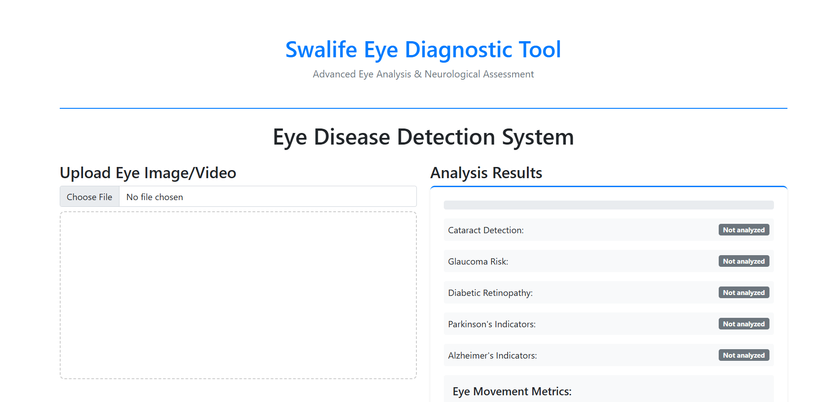
Figure 1: Swalife Eye Diagnostic Tool interface
3. Methodology
3.1 Input Processing
Images/videos undergo pre-processing to optimize detection accuracy:
- ROI extraction around the iris, sclera, and pupil
- Noise filtering and illumination correction
- Frame extraction for video-based eye movement analysis
3.2 Detection & Analysis Algorithms
The system utilizes a hybrid AI approach combining:
- Deep-learning convolutional networks for disease classification
- Feature-based analysis for optic nerve and vascular structures
- Time-series motion tracking for neurological metrics
Each algorithm predicts risk levels and extracts quantitative parameters, contributing to the final report.
3.3 Evaluation Metrics
Primary evaluation metrics include:
- Risk Scores: Low / Moderate / High
- Saccadic Velocity (deg/s)
- Pupil Response Time (seconds)
- Fixation Stability (degrees)
These metrics support both ocular and neuro-oculomotor assessment.

4. Case Study and Results
A case analysis was conducted using a patient eye image demonstrating visible lens irregularity.
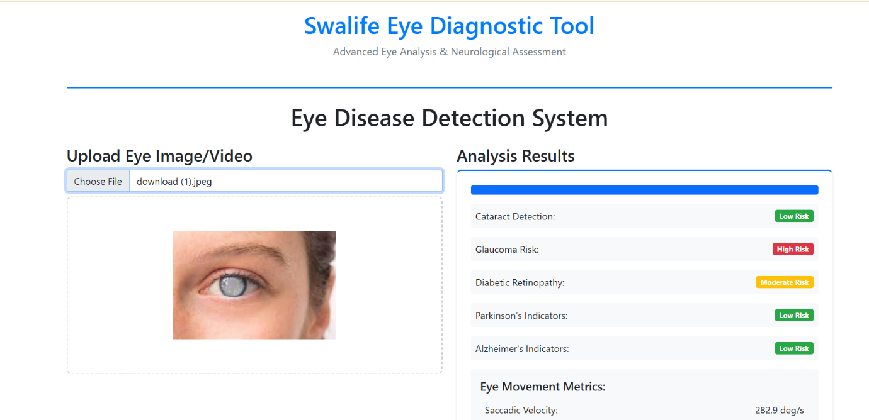
Figure 2: Case Study Report
Tool Output
Parameter | Result
Cataract Detection | Low Risk
Glaucoma Risk | High Risk
Diabetic Retinopathy | Moderate Risk
Parkinson’s Indicators | Low Risk
Alzheimer’s Indicators | Low Risk
Saccadic Velocity | 282.9 deg/s
Pupil Response Time | 0.65 s
Fixation Stability | 1.77 deg
Interpretation
The system flagged a High Risk of glaucoma, correlating with potential optic nerve stress or intraocular pressure elevation. Combined metrics indicated normal neuro-oculomotor behavior.
The integrated output demonstrates how the tool identifies priority concerns and supports clinical triage.

5. Discussion
The Swalife Eye Diagnostic Tool effectively translates ocular image data into actionable diagnostic insights. Its ability to detect multiple conditions from a single input widens its utility beyond traditional single-disease systems. The inclusion of neurological indicators provides a unique advantage, recognizing the growing field of eye–brain health assessment.
However, results depend on input quality, and certain subtle conditions may require high-resolution imaging for accurate evaluation. While AI-driven predictions offer powerful support, they are complementary and not a replacement for clinical diagnosis.

6. Advantages and Limitations
Advantages
- Integration of ocular disease and neurological assessment in one system
- Rapid and accessible screening using simple images or videos
- Automated, standardized interpretations reduce subjective bias
- Supports telemedicine and remote diagnostics
- Downloadable structured reports for clinicians
Limitations
- Accuracy may vary with poor-quality images
- Not a substitute for comprehensive ophthalmic examination
- Neurological metrics remain supportive indicators, not definitive diagnostics

7. Future Work
Future developments of the Swalife Eye Diagnostic Tool will focus on:
- Expanding detection to include age-related macular degeneration (AMD) and keratoconus
- Integration with OCT-based retinal analysis
- Advancing deep-learning models using larger multi-regional datasets
- Incorporating continuous monitoring capabilities for chronic disease management
- Enabling real-time video-based oculomotor testing protocols

8. Conclusion
The Swalife Eye Diagnostic Tool represents a significant advancement in AI-enabled ocular and neurological screening. By integrating disease detection, structural image analysis, and oculomotor metric evaluation into a unified workflow, the platform overcomes long-standing challenges associated with manual examination, equipment dependency, and variability in clinical interpretation. Its ability to process simple images or videos and produce structured, clinically meaningful insights demonstrates clear potential for improving early detection of conditions such as glaucoma, diabetic retinopathy, cataract, and neurological disorders linked to eye movement patterns.
The tool’s rapid, automated assessments make it particularly valuable for telemedicine, community screening programs, and primary care environments where specialist access is limited. While not a replacement for in-depth clinical testing, the system offers an efficient triage mechanism that can guide further diagnostic decision-making. Continued enhancement of model accuracy, dataset diversity, and imaging capabilities will further strengthen the platform’s performance. Overall, the Swalife Eye Diagnostic Tool provides a scalable, accessible, and forward-looking solution for modern eye and neuro-ocular health evaluation.

Conflicts of Interest
The authors declare no conflicts of interest.

References
- Degadwala, S., & Samajpati, S. (2024). A Review on Multiple-Ocular Disease Detection Methodology using ML and DL Techniques. International Journal of Scientific Research in Computer Science, Engineering and Information Technology. https://doi.org/10.32628/cseit2410588
- Hamza, N., Ahmed, N., & Zainaba, N. (2024). A Comparative Analysis of Traditional and AI-Driven Methods for Disease Detection: Novel Approaches, Methodologies, and Challenges. https://doi.org/10.70844/jmhrp.2024.1.2.28
- Patil, A. (2025). Hybrid Framework for Advanced Ocular Disease Diagnosis. Panamerican Mathematical Journal. https://doi.org/10.52783/pmj.v35.i2s.3197
- Band, T. G., Bar-Or, R. Z., & Ben-Ami, E. (2024). Advancements in eye movement measurement technologies for assessing neurodegenerative diseases. Frontiers in Digital Health. https://doi.org/10.3389/fdgth.2024.1423790
- Нероев, В. В., Zaytseva, O. V., Petrov, S. Yu., & Bragin, A. A. (2024). Artificial intelligence in ophthalmology: the present and the future. Российский Офтальмологический Журнал. https://doi.org/10.21516/2072-0076-2024-17-2-135-141

